Dinner Options - Walking Distance of Fairmont Chicago Millennium Park

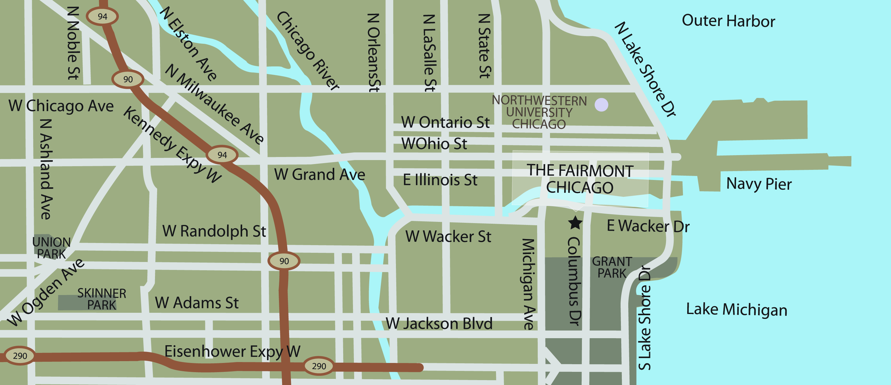
A
B
C
D
F
G
I
J
H
E K

Restaurant Cuisine

- Columbus Tap Gastro Pub
200 North Columbus Drive Lobby Level Fairmont Hotel
Phone: 312.444.9494 $$
Columbus Tap offers creative pub fare in a comfortable and contemporary environment.
The beverages will focus on local craft beers, with Midwestern sensibility also echoed in our cocktails.

- The Palm Restaurant at Swissotel Steak and Seafood
323 East Wacker Drive 0.3 miles, 5 minute walk
Phone: 312.616.1000 $$$
Directions: Walk out the main entrance to Columbus Dr., turn left one block to Wacker Dr., turn right on Wacker Dr. ½ block to The Palm Restaurant, located in the Swissotel.

- Shaw’s Crab House Seafood/Oyster Bar
21 E Hubbard St 0.8 miles, 15-20 minute walk
Phone: 312.527.2722 $$$
Directions: walk out the main entrance to Columbus Dr., turn left one block to Wacker Dr., turn left on Wacker Dr., 4 blocks to State St., turn right on State Street (cross river) 3 blocks to Hubbard St., turn right on Hubbard St. Shaw’s is located on the right-hand side.

- Bella Bacino Casual Pizza & Pasta
75 East Wacker Drive 0.5 miles, 10-15 minute walk
Phone: 312.263.0070 $$
Directions: walk out the main entrance to Columbus Dr., turn left one block to Wacker Dr., turn left on Wacker Dr., to Bella Bacino. Bella Bacino’s is located on the left-hand side. (½ block past Michigan Avenue)

- The Gage American w/Irish influence
24 South Michigan Avenue 0.4 miles, 10-15 minute walk
Phone: 312.372.4243 $$
Directions: walk out the main entrance to Columbus Dr., turn right one block to Randolph St., turn right on Randolph St., one block to Michigan Ave., turn left on Michigan Ave. The Gage is located 2 ½ blocks down on the right-hand side of Michigan Ave.

- Volare Northern Italian
201 East Grand Avenue 0.7 miles, 10-15 minute walk
Phone: 312.410.9900 $$
Directions: walk out the main entrance to Columbus Dr., turn left one block to Wacker Dr., cross Wacker Dr., and take the stairs on the right down one level. (cross river) on Columbus Dr. walk 3 blocks to Grand Ave., turn left on Grand Ave. Volare is on the left hand side of Grand Ave.

- Tavern at the Park Casual American
130 East Randolph Street 0.2 miles, 5 minute walk
Phone: 312.552.0070 $$
Directions: walk out the main entrance to Columbus Dr., turn right one block to Randolph St., turn right on Randolph St., walk ½ blocks to Tavern at the Park.
Tavern at the Park is closed on Sundays.

- The Purple Pig Mediterranean/Pork Centric
500 N Michigan Ave 0.6 miles, 10-15 minute walk
Phone: 312.464.1744 $$
Directions: walk out the main entrance to Columbus Dr., turn left one block to Wacker Dr., turn left on Wacker Dr., walk two blocks to Michigan Ave., turn right on Michigan Ave., walk 3 block. The Purple Pig will be on the left-hand side of Michigan Ave.

The Purple Pig does not accept reservations, and due to the restaurant’s popularity the wait can long. We suggest dining before 6pm or after 9pm.

- Sunda New Asian/Sushi
110 W Illinois St 1 mile, 15-20 minute walk
Phone: 312.644.0500 $$$
Directions: walk out the main entrance to Columbus Dr., turn left one block to Wacker Dr., turn left on Wacker Dr., walk. 6 blocks to Clark St., turn right on Clark St., (cross river) 4 blocks to Illinois St., turn left on Illinois St. Sunda is located on the right-hand side.

- Mercadito Mexican Tapas
108 W Kinzie St 0.9 miles, 15-20 minute walk
Phone: 312.329.9555 $$
Directions: walk out the main entrance to Columbus Dr., turn left one block to Wacker Dr., turn left on Wacker Dr., walk 6 blocks to Clark St., turn right onto Clark St (cross river) 1 block to Kinzie St., turn left on Kinzie.St. Mercadito is located on the right-hand side of Kinzie St.

- Acanto Italian
18 S Michigan Ave. 0.4 miles, 10-15 minute walk
Phone: 312-578-0763 $$$
Directions: walk out the main entrance to Columbus Dr., turn right one block to Randolph St., turn right on Randolph St., one block to Michigan Ave., turn left on Michigan Ave. Acanto is located 2 ½ blocks on the right-hand side of Michigan Ave.

