Lunch Options - Walking Distance of Fairmont Chicago Millennium Park

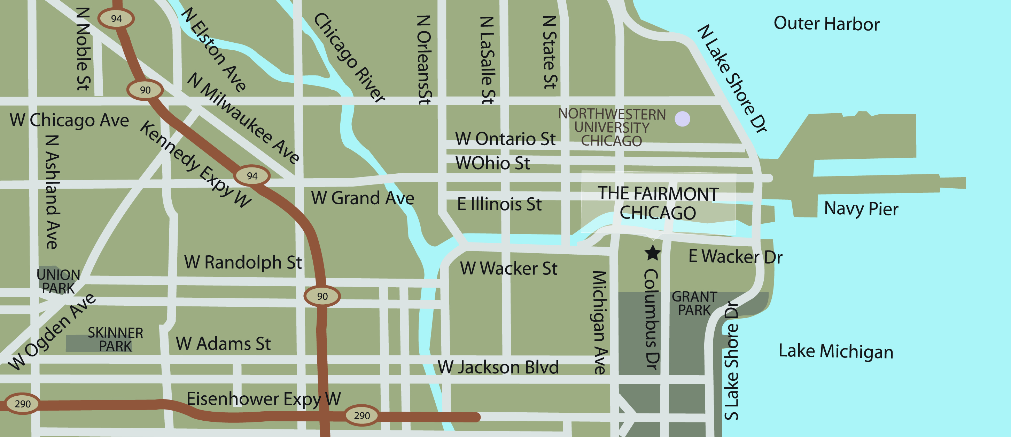
E K
J
I
C
H
F
D
G
B
A

Restaurant Cuisine

- Columbus Tap Gastro Pub
200 North Columbus Drive Lobby Level Fairmont Hotel
Phone: 312.444.9494 $$
Columbus Tap offers creative pub fare in a comfortable and contemporary environment.
The beverages will focus on local craft beers, with Midwestern sensibility also echoed in our cocktails.

- Aon Center Pedway Eateries
Market Tyme Variety of Stations
Au Bon Pain Café Sandwiches and Salads
Jimmy Johns Sandwiches
Soprafina Italian Fare
Directions: get off any Fairmont elevator or escalator on B-1 and walk to the end of the corridor for the
Aon Center pedway connection for these various lunch spots. The food court is open Monday through
Friday only.

- Tavern at the Park Casual American
130 East Randolph Street 0.2 miles, 5 minute walk
Phone: 312.552.0070 $$
Directions: walk out the main entrance to Columbus Dr., turn right one block to Randolph St., turn right on Randolph St., walk1 block to Taverm at the Park.
Tavern at the Park is closed on Sundays.

- Hannah’s Bretzel Organic/Sandwiches
233 North Michigan Avenue 5 minute walk
Phone: 312.621.1111 $
Directions: walk out the main entrance to Columbus Dr., turn left one block to Wacker Dr., turn
left on Wacker Dr., walk one block, enter the West Tower of the Hyatt Hotel, go down the escalator and follow the signs for “Illinois Center”. Only Open Monday – Friday 8am – 7pm

- Wildberry Café/Breakfast
130 East Randolph Street 5 minute walk
Phone: 312.552.0070 $
Directions: walk out the main entrance to Columbus Dr., turn right one block to Randolph St.,
turn right on Randolph St., walk ½ a block on Randolph St. Wildberry is located on the right.

- Sweetwater Tavern Casual American
225 North Michigan Avenue 5 minute walk
Phone: 312.698.7111 $
Directions: walk out the main entrance to Columbus Dr., turn left one block to Wacker Dr., turn left on Wacker Dr., 2 blocks to Michigan Ave., turn left on Michigan Ave., one block to Sweetwater, on the comer of South Water St. and Michigan Ave.

- Brown Bag Seafood Seafood, Healthy
340 East Randolph Street 5 minute walk
Phone: 312.496.3999 $
Directions: walk out the main entrance to Columbus Dr., turn right one block to Randolph St., turn left on Randolph St. Brown Bag Seafood is located on the left hand side next to Chase Bank. Closed on Sundays

- Bella Bacino Casual Pizza & Pasta
75 East Wacker Drive 0.5 miles, 10-15 minute walk
Phone: 312.263.0070 $$
Directions: walk out the main entrance to Columbus Dr., turn left one block to Wacker Dr., and turn left on Wacker Dr., to Bella Bacino. Bella Bacino’s is located on the left-hand side. (½ block past Michigan Avenue)

- The Gage American w/Irish influence
24 South Michigan Avenue 0.4 miles, 10-15 minute walk
Phone: 312.372.4243 $$
Directions: walk out the main entrance to Columbus Dr, turn right one block to Randolph St., turn right on Randolph St., one block to Michigan Ave., turn left on Michigan Ave. The Gage is located 2 ½ down on the right-hand side of Michigan Ave.

